Cullen and Frey Graph for : r1a

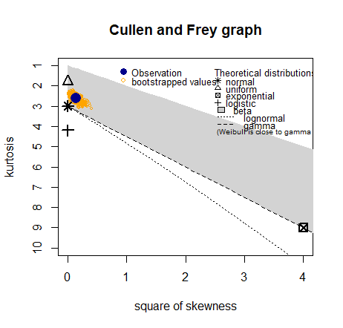

Cullen and Frey Graph for: r1c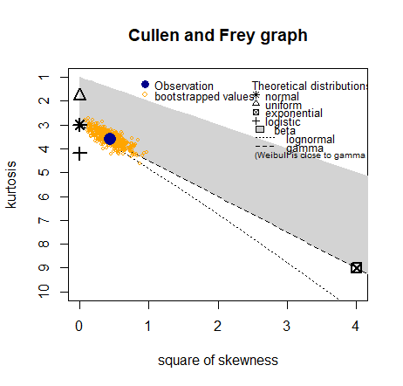

Cullen and Frey Graph for: r1m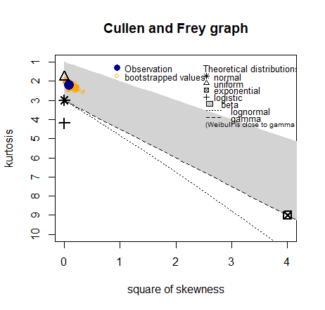

Cullen and Frey Graph for: r1mw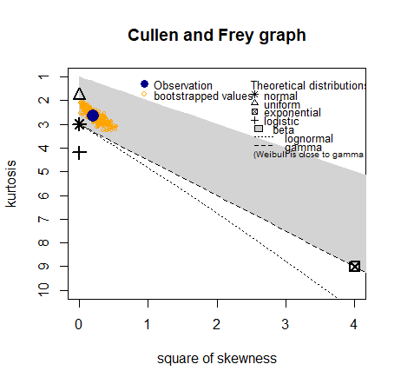

Cullen and Frey Graph for: r2a

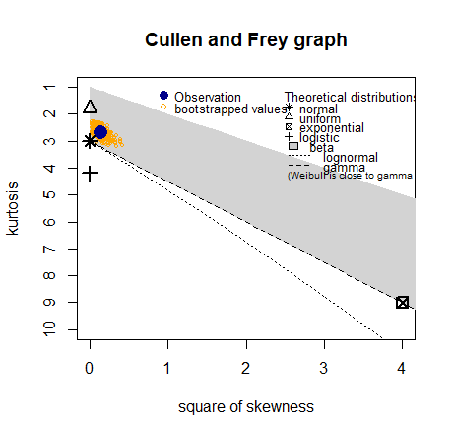

Cullen and Frey Graph for:r2c

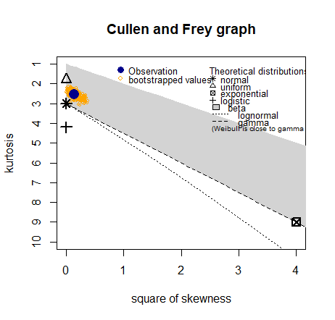

Cullen and Frey Graph for:r2m

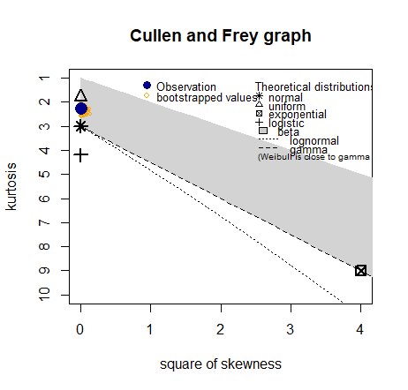

Cullen and Frey Graph for:r2mw

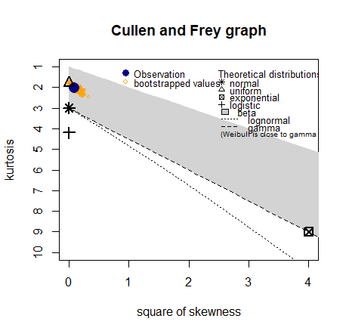

Cullen and Frey Graph for:r3a

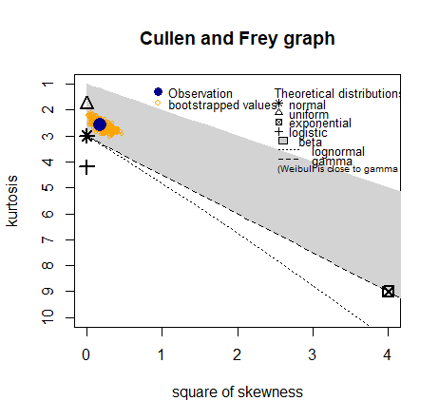

Cullen and Frey Graph for:r3c

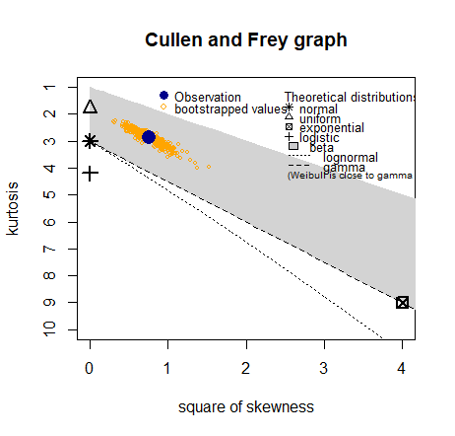

Cullen and Frey Graph for:r3m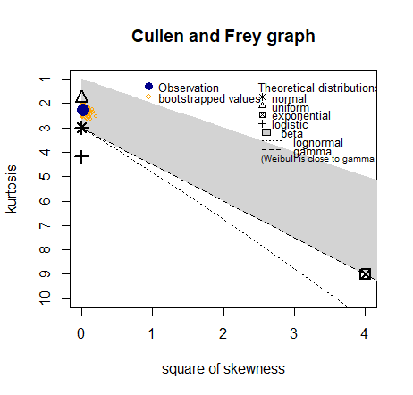

Cullen and Frey Graph for:r3mw

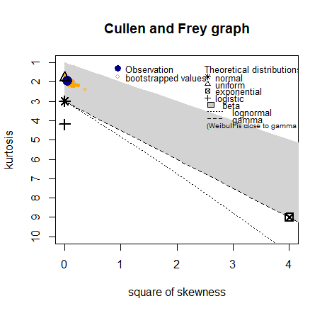

Cullen and Frey Graph for:r4a

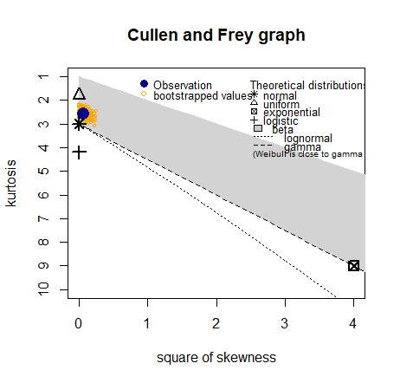

Cullen and Frey Graph for:r4c

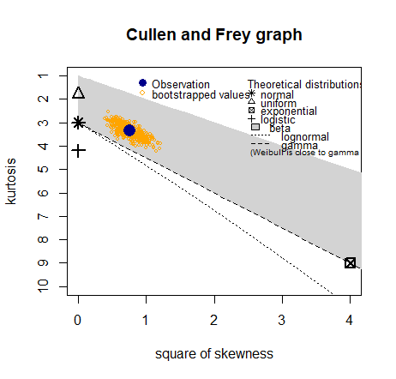

Cullen and Frey Graph for:r4m

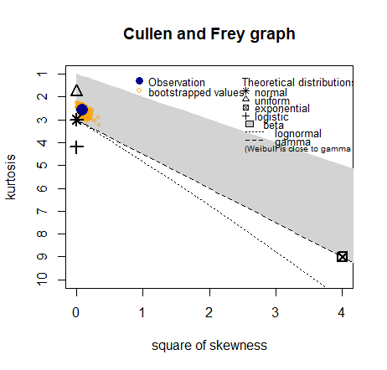

Cullen and Frey Graph for:r4mw

